Kim Kardashian files for divorce from Kanye West regardless of seven years of marriage
By EvodeUwiragiye
Huye 23rd Feb 2021
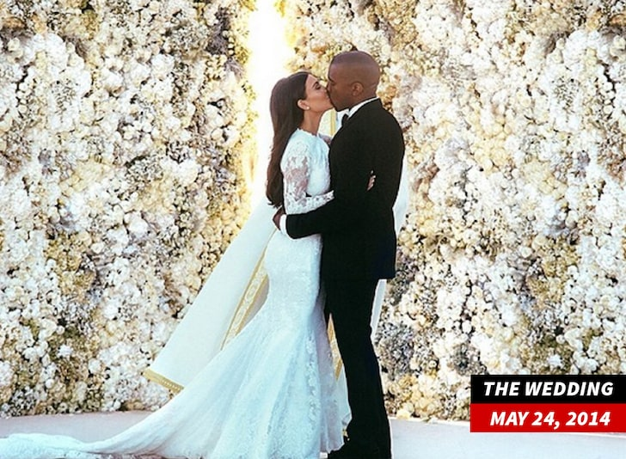
Kanye West and His Wife Kim Kardashian at wedding day in May 24,2014
Photo by TMZ
The long lasted HollyWood couple shook the world of entertainment when the news that they may divorce got published . On 20th Feb 2020, TMZ as one of the trusted sources of entertainment news announced that Kim Kardashian filed for the divorcefrom his rapstar husband Kanye West a.k.a Ye.

By the middle of 2020, Kim Kardashian started showing the signs that her couple is no longer at its rose flower like before. This came as the result of Kanye West(Ye)'s words that he announced when he was running for the US presidency post as a minor candidate. He reaveled how Kim tried to abort their first kid back in the days in 2013.After revealing all these about his family, Kanye West(Ye) got attacking tweets from The Kardashian family that was never happy with the words that he announced.
“He is a brilliant but complicated person who on top of the pressures of being an artist and a black man, who experienced the painful loss of his mother, Donda West, who died suddenly at 58 from surgical complications in 2007, he has to deal with the pressure and isolation that is heightened by his bipolar disorder” Kim Kardashian told TMZ approving how his husband is suffering from bipolar disorder as a source of announcing the familiar secrets.
Later on , Kanye West by using his twitter account, he appologized for what he earlier announced as a secret matter.
“I would like to appologize to my wife Kim for going public with something that was a private.I did not cover her like she has covered me. To Kim, I want to say I know I hurt you. Please forgive me. Thank you for always being there for me.” Kanye West tweeted appologizing to his wife Kim.


Reminding you that Kanye and Kim first met in 2000 and he appeared on ‘Keeping up the Kardashians’ show in 2010 when he visited her and Kourtney’s DASH store in NYC and Kim was at the time dating with Kris Humphries.
Kanye hesitated a little bit until he released the “Cold” track to show how really he loved Kim and soon they started dating obviously.
As of right now, Kim and Kanye that go by the name of Kimye as a couple,have only four children-North,Chicago,Psalm and Saint who is current their lastborn with 21 months old.
However, the divorce is said to be an imminent .

